# CS 255 System Design Document Template

## UML Diagrams

### UML Use Case Diagram

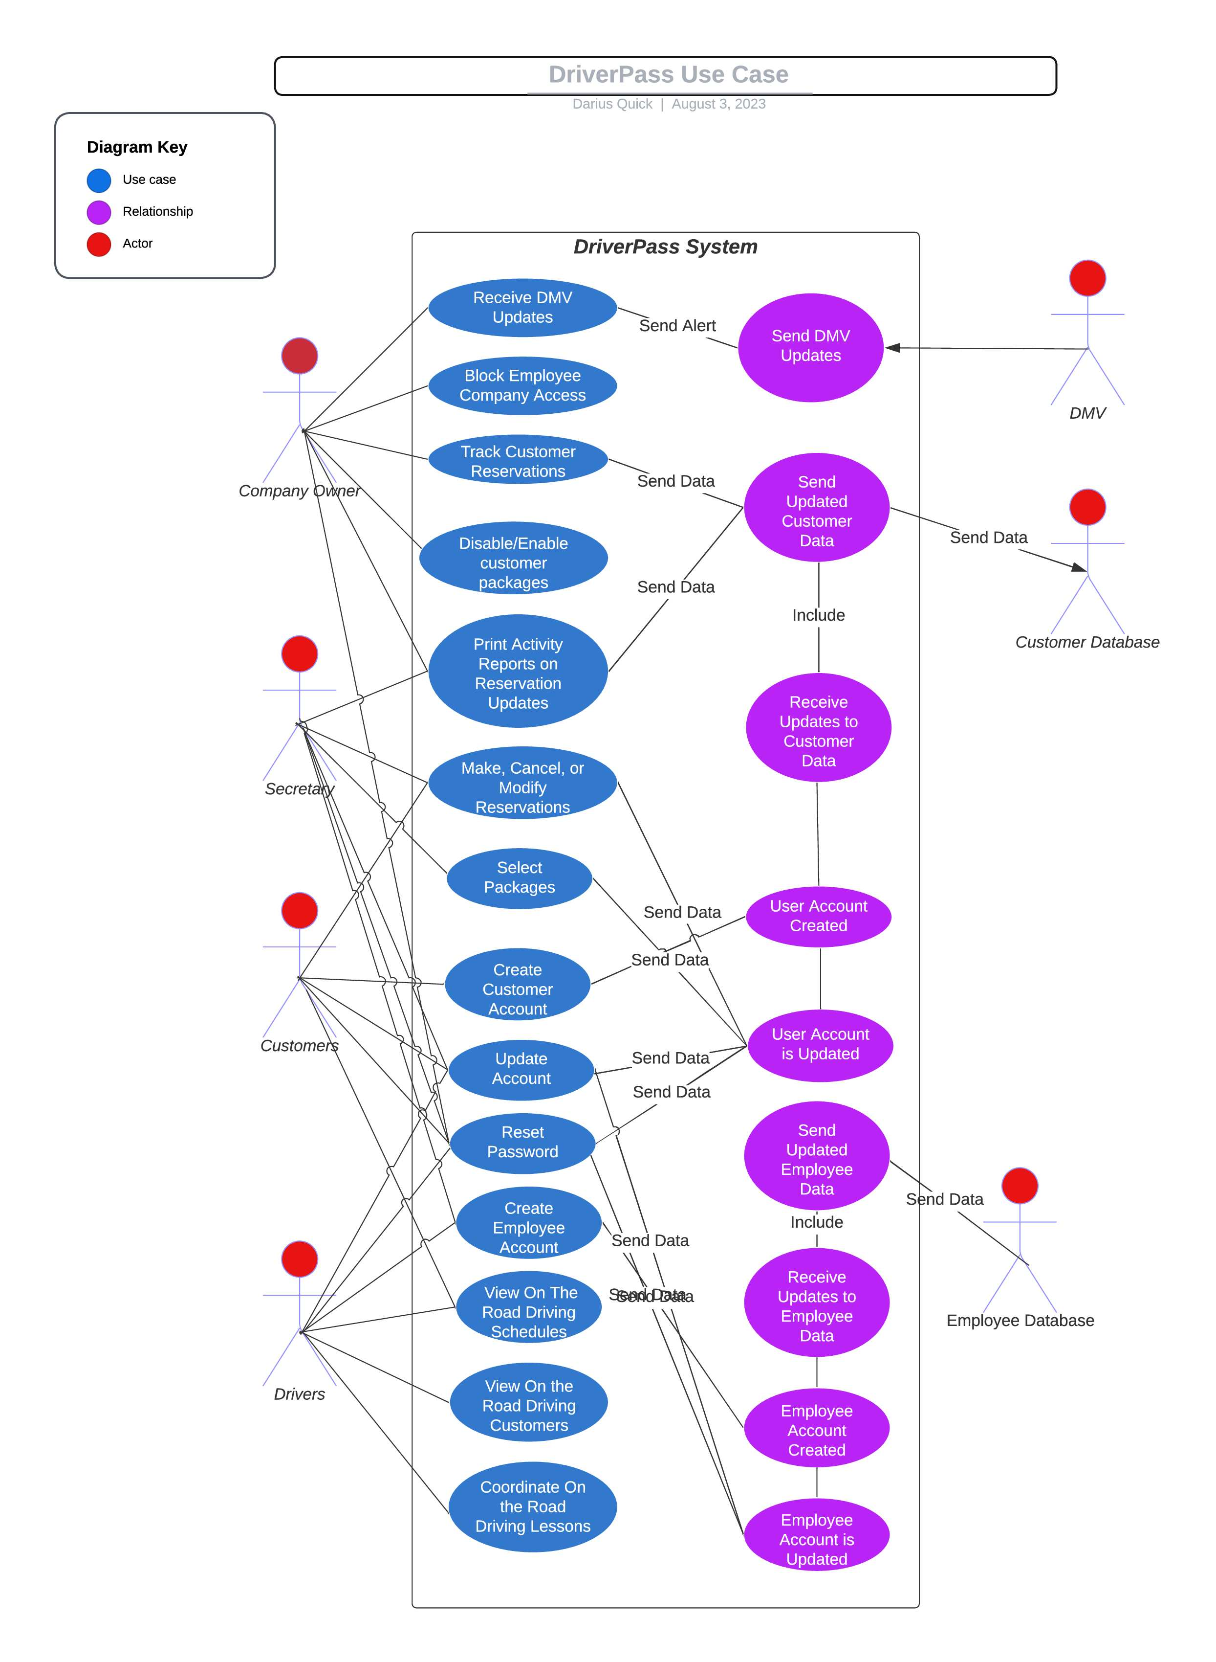

### UML Activity Diagrams

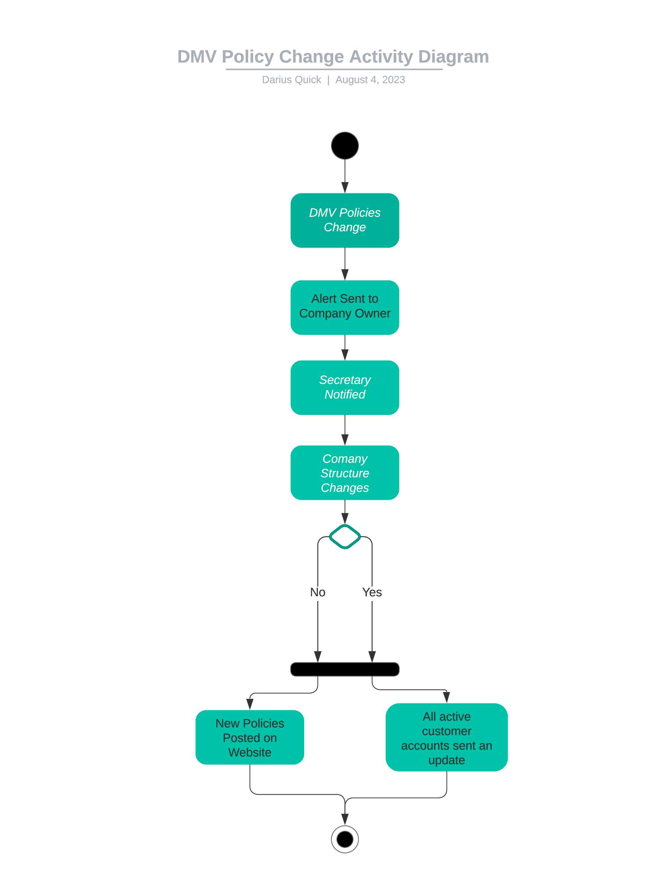

### UML Sequence Diagram

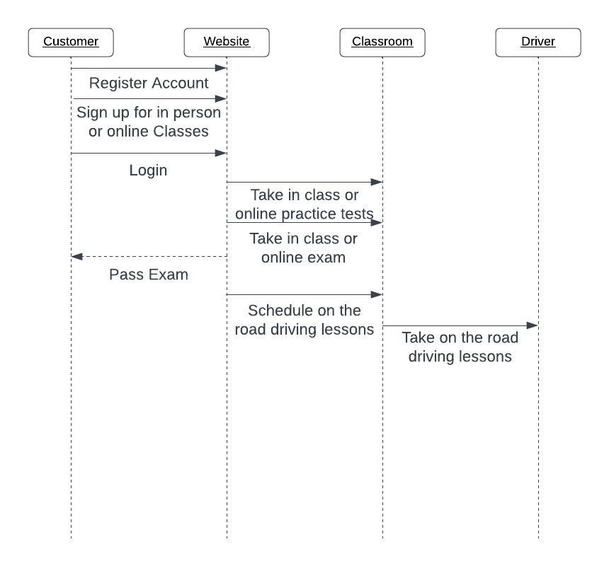

### UML Class Diagram

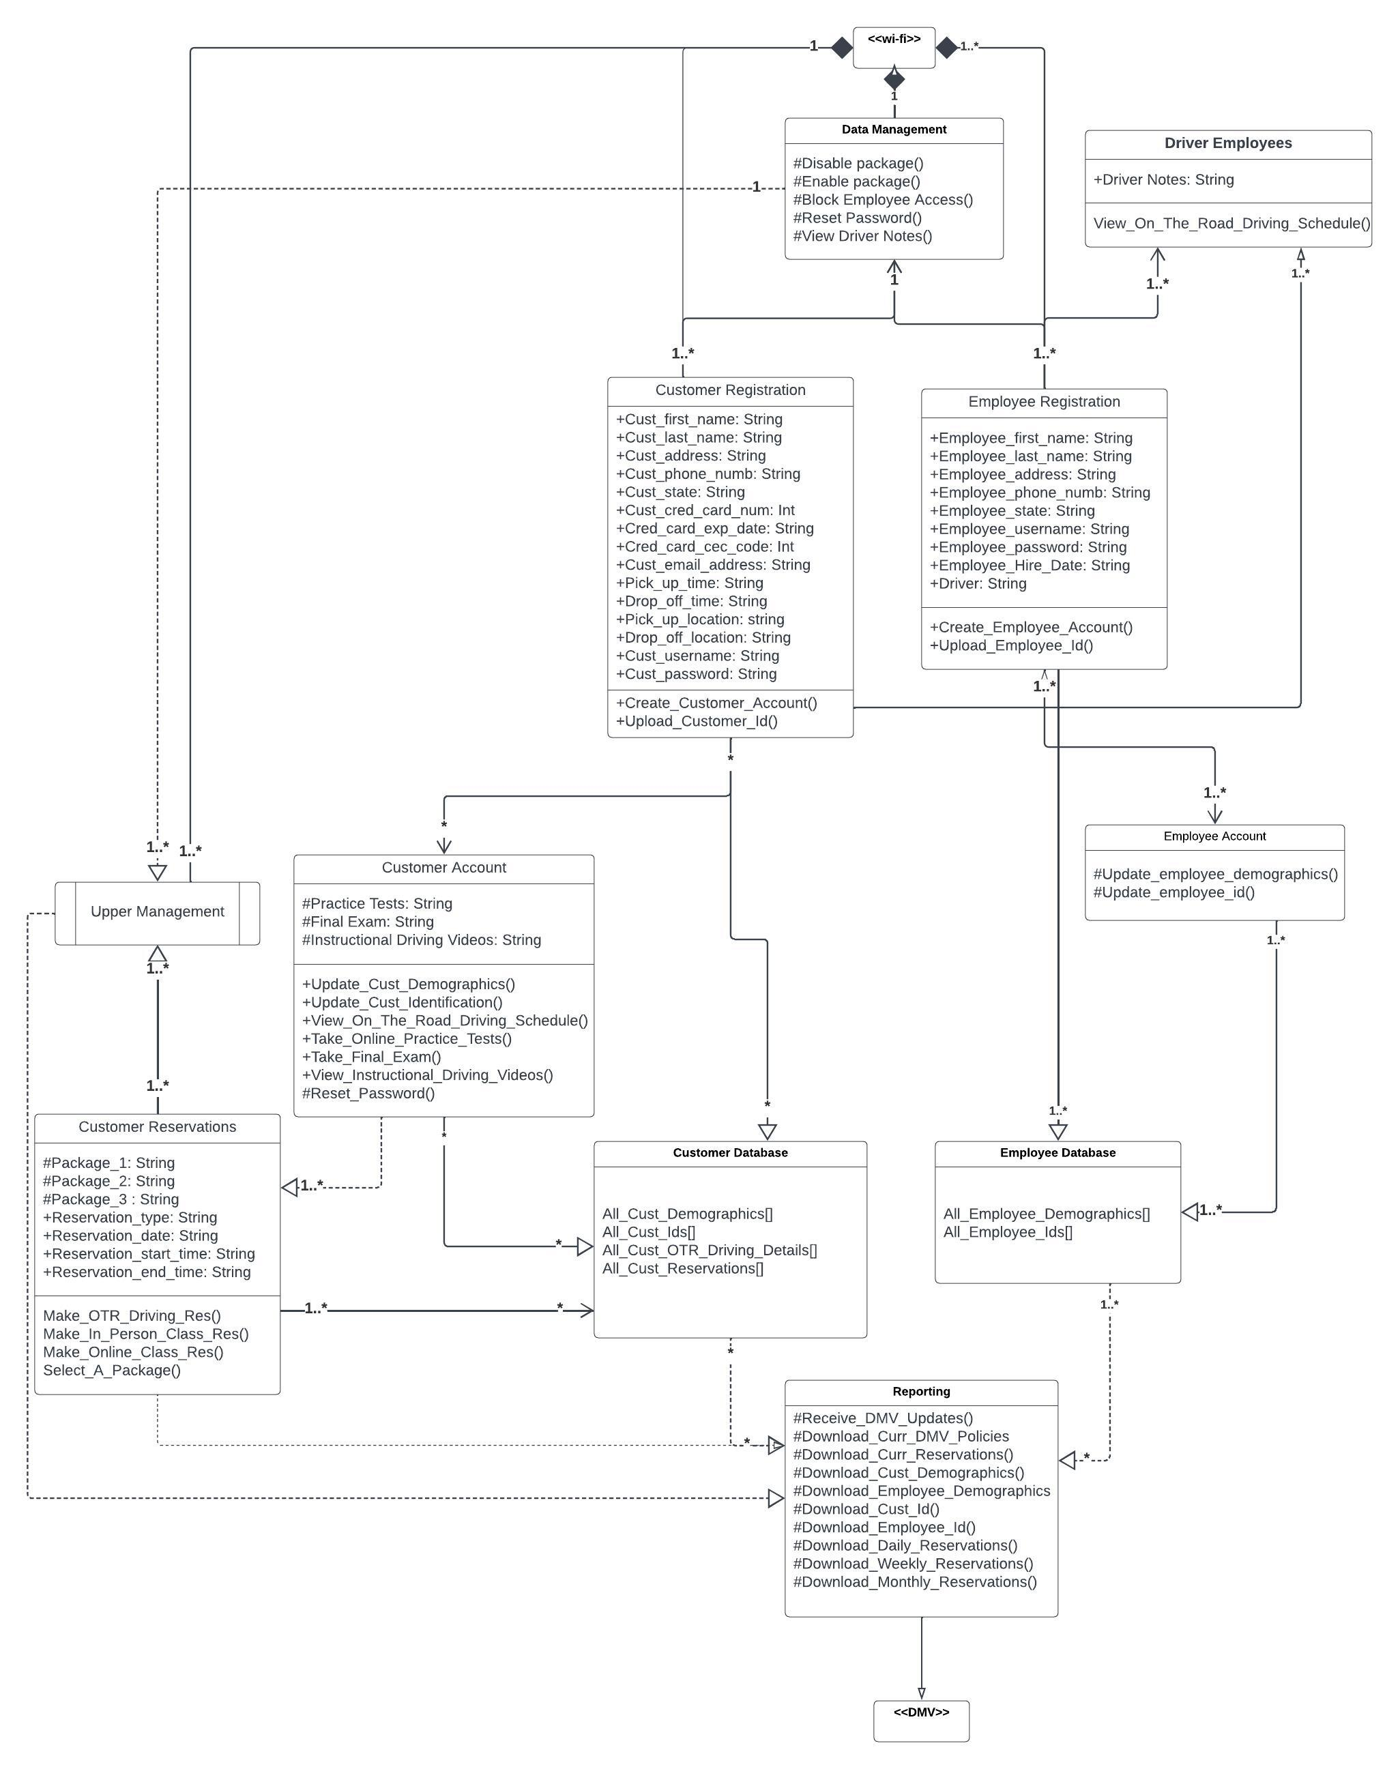

## Technical Requirements

Hardware:

* Laptop, overhead projector, and screen for the in-class teacher to present
* Desktop or Laptop computers that can handle the DriverPass system
* A printer in the office to have reports printed to
* A printer for the company owner to print reports to if he is unable to go to the office

Software:

* Email account and software access so that the main workers in the company can communicate and DMV updates can be received
* Database software such as excel for customer and employee information to go to and reports to be pulled from
* Cloud based server large enough for the DriverPass system, the Customer Database, and the Employee Database to be on
* Software for the instructional driving videos to be viewed on
* Software for practice tests and final exam to be taken on

Tools:

* Wi-fi Access for non-mobile devices being used
* Mobile devices and wi-fi for the drivers, company owner, and secretary
* Wi-fi extender so that wife can reach around the whole company building